Please answer all the questions accordingly and submit the solution.

**Ques-1 Consider the following table employees**

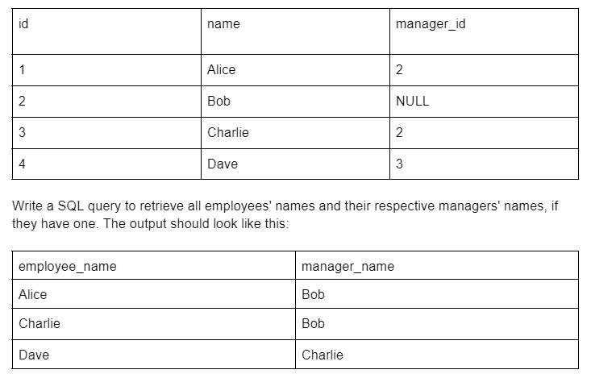

**Ques 2- Now suppose we want to find the names of all employees who do not have a manager. Write a SQL query to retrieve this information from the employee's table.**

**Ques-3 Consider the following table sales**

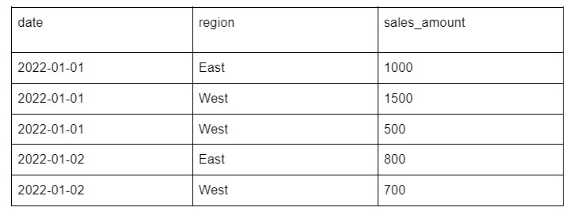

**Write a SQL query to calculate the total sales amount for each region, grouped by date. The output should look like this:**

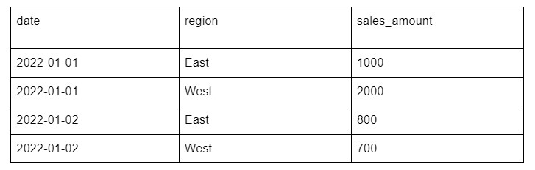

**Ques 4-Create a view based on the query you wrote in the previous question. Name the view daily_sales_by_region.**

**Ques-5 Write a SQL query to select all rows from the daily_sales_by_region view where the total_sales for a given date and region is greater than 1000. The output should look like this:**

